3. TRAFFIC LIGHT CONTROL SYSTEM
Aim:
To implement a one way and two way traffic light control system.
ONE WAY DIRECTION:
Problem statement:
Red light glows for 30s, yellow light for 5 s, green light for 25s and this process continues. There is a start button and a stop button. Draw the ladder logic to implement the above process.
Flow diagram:
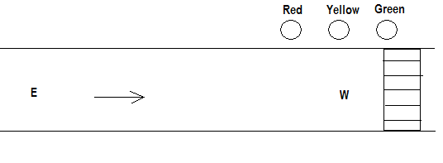
Ladder Logic:

TWO WAY DIRECTION:
When Red 1 is ON for 30s, E-W traffic flows. At this instant, Yellow 2 becomes ON for 5s after which Green 2 becomes ON for 25s. After 30s, when Red 2 is ON for 30s, N-S traffic flows. At this instant, Yellow 1 becomes ON for 5s after which Green 1 becomes ON for 25s and this process continues. There is a start button and a stop button. Draw the ladder logic to implement the above process.

Flow diagram:
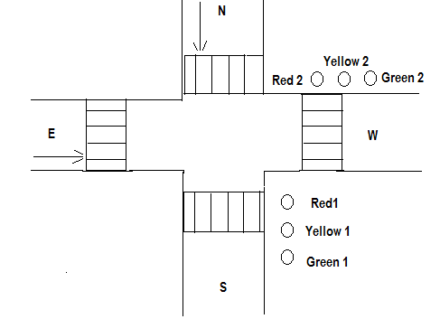

Ladder Logic:

Result:
Thus the one way and two way traffic light control was executed and verified using PLC.

